Regression Analysis of Airbnb Listing Prices Based on Listing Attributes
Sasha Johnson
Stat 311
Iresha Premarathna
April 28, 2026

INTRODUCTION
This analysis aims to investigate the factors that influence AirBnB listing prices. Specifically, the primary research question is:

Which listing characteristics, host attributes, and availability factors significantly affect the price of an AirBnB listing?

Predictors such as property attributes, listing characteristics, host features and availability have potential to influence the price in systematic ways. Understanding these relationships is important from both sides of the transaction (customers and hosts). Hosts can use information similar to what may be found in this analysis to determine optimal pricing strategies, improve listing competitiveness and maximize revenue. At the same time, customers can better understand what properties may be properly priced (good vs bad value) and what factors contribute most to price, helping make informed decisions.
To complete the analysis, exploratory analysis is performed to understand the structure of the data, identify patterns, and detect some potential early flags that could lead to issues such as skewness or outliers. An initial MLR model is then fitted using price to evaluate relationships between predictors and price. Analysis of the initial model will be performed to assess whether regression assumptions are satisfied. Based on findings, transformations or alternative modeling strategies will be considered. The final model will be selected based on statistical adequacy, interpretability and simplicity.
DATASET
The dataset used in this analysis was compiled by InsideAirbnb.com, a platform focused on providing publicly accessible Airbnb data and analysis. The data is collected through web scraping techniques applied to Airbnb listings. This particular dataset includes listings located in Denver, Colorado. It contains several thousand observations, providing a sufficiently large sample size for regression analysis. The dataset includes a wide range of variables related to pricing, property characteristics, host information, review metrics, and availability.
Each observation in the dataset represents a single Airbnb listing created by a host. Listing prices are determined by hosts based on various factors, including property size, amenities, location, and perceived demand. Additional variables, such as review counts and ratings, are generated through guest interactions with the platform. Because the dataset is observational in nature and reflects real-world market behavior, the relationships identified in this analysis represent associations rather than causal effects. The dataset also exhibits characteristics typical of real-world data, including variability in property attributes, skewness in price, and the presence of extreme values.
The variables used for this analysis are as follows

Dependent Variables (DV, Response):
- Price - Listed in Dollars ($), Numeric
- Log(Price) - Logarithm of price (Used to address skewness and improve model fit, this will be addressed later), Numeric/transform

Independent Variables (IV, Predictors):
Property Characteristics (Numeric)
$x_{1}$ = Accommodates - Number of guests the listing can accomodate
$x_{2}=$Bathrooms - Number of Bathrooms in the listing
$x_{3}=$Extra_beds¹ - Difference in number of beds and bedrooms in a listing
$x_{4}=$Bedrooms - Number of bedrooms in the listing
Reviews (numerical)
$x_{5}=$Reviews_per_month - Average number of reviews per month on a listing
$x_{6}=$Review_scores_rating - Overall review score given by guests
Listing Attributes (categorical) – Using Dummy Variables
$x_{7-9}=$Room_type - Type of listing (entire home/apt, private room, shared room, hotel room)
Baseline = entire home/apt
$x_{7}=\left\{\begin{aligned}1if private room \\ 0 if otherwise\end{aligned}\right. x_{8}=\left\{\begin{aligned}1if shared room \\ 0 if otherwise\end{aligned}\right.$ $x_{9}=\left\{\begin{aligned}1if hotel room \\ 0 if otherwise\end{aligned}\right.$

EXPLORATORY DATA ANALYSIS (EDA)
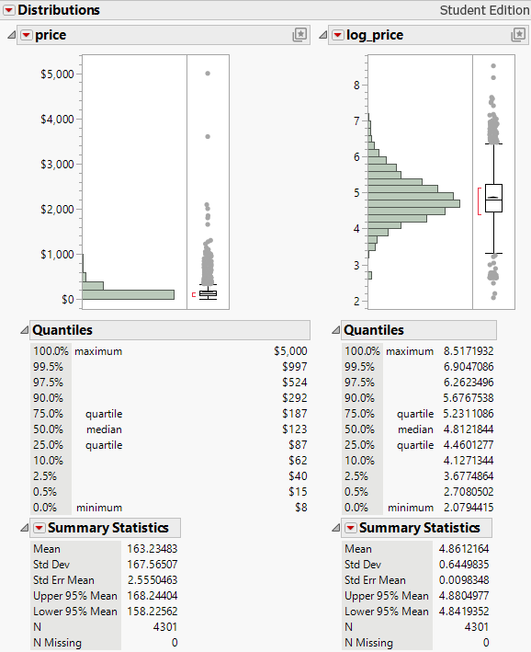
The distribution of price is heavily right-skewed, with most listings concentrated at lower values and a long tail of higher-priced listings, including some extreme values up to $5,000. This is also reflected in the summary statistics, where the mean ($163) is noticeably higher than the median ($123), confirming the skewness. In contrast, the distribution of log(price) is much more symmetric and centered, with the mean and median much closer together. The log transformation compresses the higher values and reduces the impact of extreme listings, resulting in a more balanced spread of the data. Because of this, log(price) is more appropriate for regression, as it better satisfies key assumptions such as normality of the errors and constant variance.
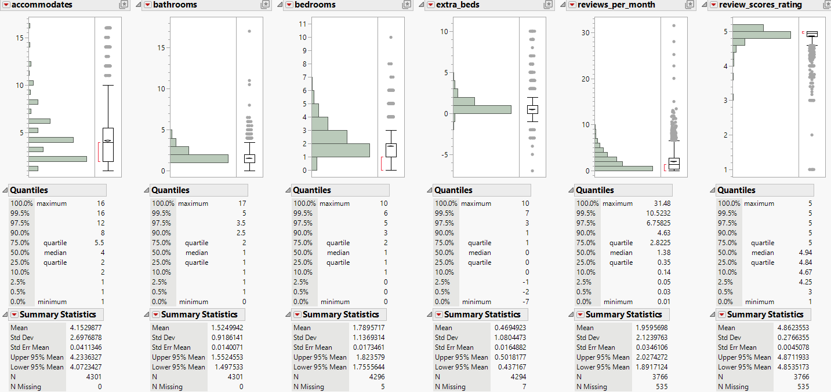
The distributions of the predictor variables show that most size-related variables, such as accommodates, bedrooms, and bathrooms, are reasonably centered with slight right skew and a few higher-value outliers. The extra_beds variable is mostly concentrated around zero, indicating that many listings follow a one-bed-per-bedroom setup, with some variation capturing shared sleeping arrangements. Reviews_per_month is heavily right-skewed, with most listings having low review activity and a few with much higher values. Review_scores_rating is tightly clustered near the upper end of the scale, showing that most listings receive high ratings with limited variation. Overall, the variables appear usable for regression, though some skewness and outliers are present.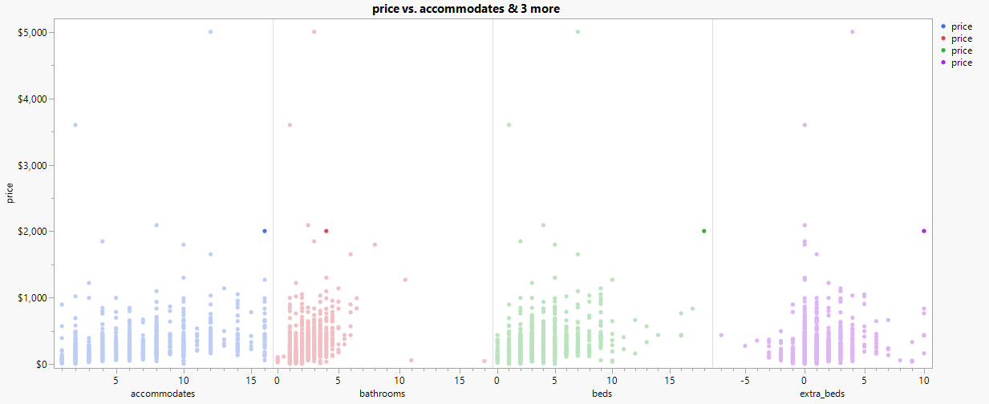
The relationship between price and the size-related variables shows a general upward trend, although it is somewhat distorted by outliers. In general, listings that accommodate more guests and have more bathrooms and bedrooms tend to have higher prices. Interestingly, the extra_beds variable shows more of a loose bell-shaped pattern, suggesting that sleeping arrangements, not just the total number of beds, may play a role in affecting price.
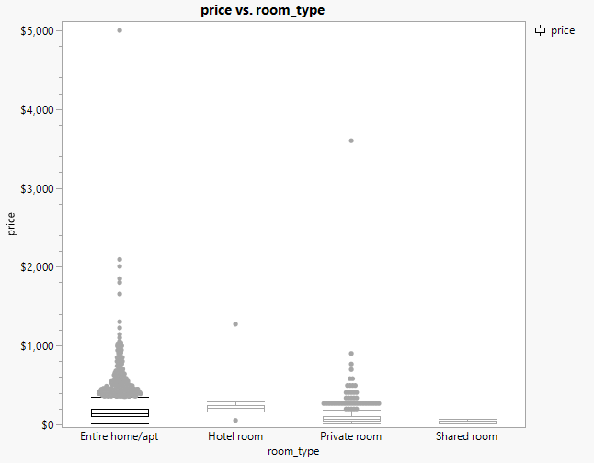
Price varies by room_type with entire home/apartment listings generally having higher prices and shared rooms with the lowest. Somewhat expected if you were to venture a guess and rent on your own.
Overall, the EDA suggests that while several predictors show relationships with price, the presence of skewness, outliers, and variability indicates that model refinement and transformation may be necessary.
METHODS AND ANALYSIS
This study uses an observational design based on the dataset described above. Because data is not collected through a controlled experiment, the relationships identified show associations rather than causal effects. The following models use multiple linear regression to model price as a function of property characteristics, listing attributes and review-related variables. Higher-order and interaction terms were considered, but exploratory analysis did not suggest strong nonlinear relationships, and the focus was placed on maintaining a simple and interpretable model. Entries with missing price values were excluded. Outliers noticed in the EDA were included as they appeared to be legitimate entries with no evidence suggesting they were invalid². Variance Inflation Factors (VIF) were examined to assess multicollinearity among predictors. Moderate multicollinearity was observed between accommodates and bedrooms, which is expected due to their related interpretation as measures of listing size. However, all variables were retained in the model. Influential observations were also considered using Cook’s Distance. While some observations exhibited higher influence, they were determined to be valid data points and were retained in the analysis.
Model 1:
$$E\left\{y\right\}=β_{0}+β_{1}x_{1}+ β_{2}x_{2}+ β_{3}x_{3}+β_{4}x_{4}+β_{5}x_{5}+β_{6}x_{6}+ β_{7}x_{7}+ β_{8}x_{8}+ β_{9}x_{9}$$
Hypothesis:
$$H_{O} : β_{i}=0 where i=1-9$$
$$H_{A} :at least one β_{i} ≠0 where β_{i}=1-9$$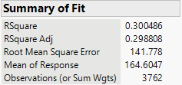

Model 1 explains ~30% of the variation in price given our R² value of 0.3005. Our adj R² is very similar, indicating that after accounting for the variables, the model maintains a comparable explanatory power. The overall f-test shows that model is statistically significant (p-value < 0.05), providing evidence that at least one of the betas is not equal to zero. We reject the null hypothesis and accept the alternative hypotheses. The parameter estimates show that all the size related variables ($x_{1}-x_{4})$ are significant.
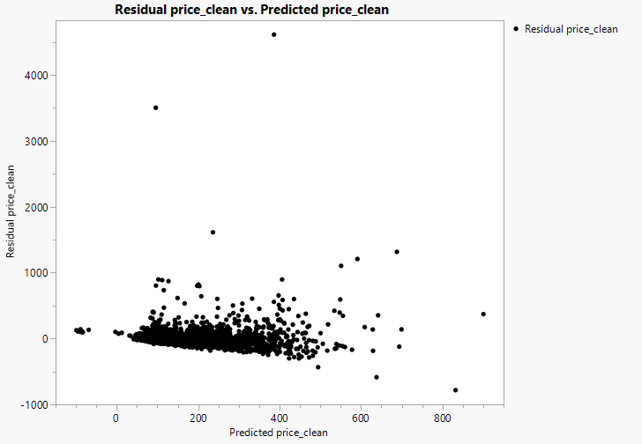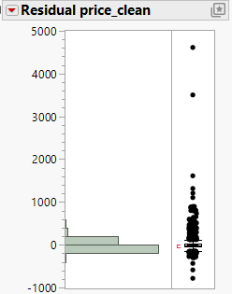
The residuals versus predicted values plot shows clear funnel shape, indicating non-constant variance as the spread of residuals increases with higher predicted prices. The histogram residuals support in showing a strong right skew with several outliers. The residuals are not normally distributed. Model 1 violates key regression assumptions.
Model 2:
Because model 01 produced a relatively low R² value I will explore a simpler model focused only on core listing characteristics to see if it will provide similar explanatory power. Model 02 will remove review related variables to allow us to isolate the effect of actual qualities of the property, rather than user reviews.
$$E\left\{y\right\}=β_{0}+β_{1}x_{1}+ β_{2}x_{2}+ β_{3}x_{3}+β_{4}x_{4}+ β_{7}x_{7}+ β_{8}x_{8}+ β_{9}x_{9}$$
Hypothesis:
$$H_{O} : β_{i}=0 where i=1-4, 7-9$$
$$H_{A} :at least one β_{i} ≠0 where β_{i}=1-4, 7-9$$

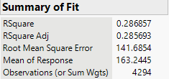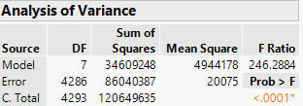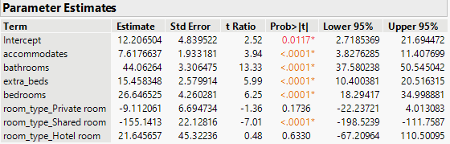
Model 2 explains ~28.7% of the variation in price given our R² value of 0.2869. Our adjusted R² is very similar, indicating that after accounting for the variables, the model maintains a comparable explanatory power. The overall F-test shows that the model is statistically significant, providing evidence that at least one of the betas is not equal to zero. We reject the null hypothesis in favor of the alternative hypothesis. The parameter estimates show that all the size related variables are significant. We are seeing very similar results to model 1 here.
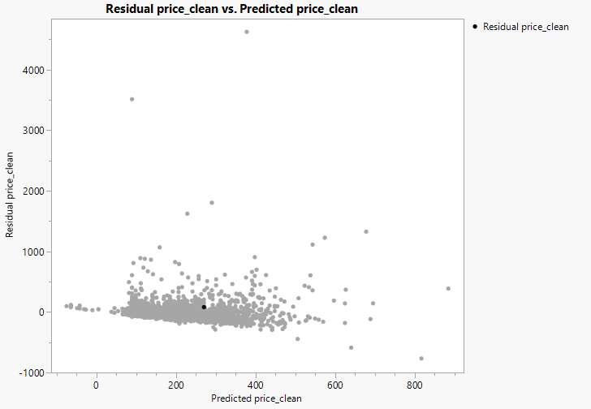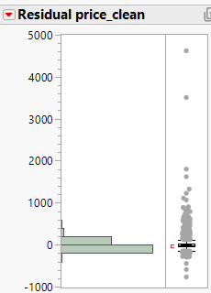
Again, we are seeing similar results to model 1 here. The residuals versus predicted values plot shows a clear funnel shape, indicating non-constant variance as the spread of residuals increases with higher predicted prices. The histogram of residuals supports this by showing a strong right skew with several outliers. The residuals are not normally distributed. Model 2 violates key regression assumptions.
Model 3:
Because model 1 and model 2 produced very similar results (they are similar models after all) we are unlikely to achieve meaningful improvement in model accuracy through further selection or modification of the IV’s themselves. With model 3 the goal is to transform the price data (response variable). The price data is heavily right-skewed and exhibits non-constant variance, so taking the logarithm³ of price helps produce a more normally distributed and centralized response, while also stabilizing variance. This is expected to better satisfy regression assumptions and improve overall model performance.
$$E\left\{log⁡(y)\right\}=β_{0}+β_{1}x_{1}+ β_{2}x_{2}+ β_{3}x_{3}+β_{4}x_{4}+β_{5}x_{5}+β_{6}x_{6}+ β_{7}x_{7}+ β_{8}x_{8}+ β_{9}x_{9}$$
Hypothesis:
$$H_{O} : β_{i}=0 where i=1-9$$
$$H_{A} :at least one β_{i} ≠0 where β_{i}=1-9$$
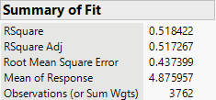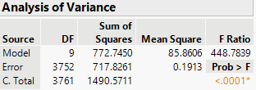
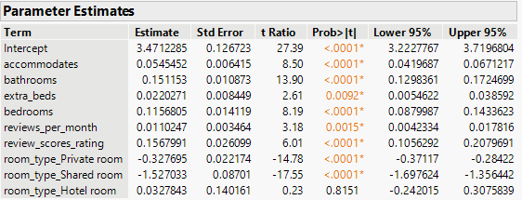
Model 3 explains ~51.8% of the variation in log(price) given our R² value of 0.5184. The adjusted R² value is very similar indicating that after accounting for the variables, the model maintains comparable explanatory power. The overall F-test shows that the model is statistically significant, providing evidence that at least one of the betas is not equal to zero. Therefore, we reject the null hypothesis and accept the alternative hypothesis.
It is important to note that in this model due to the transformation of the response variable, the betas are now interpreted in terms of percentage changes in price. The size variables all have significant positive relationships with price, indicating that they drive price up as they themselves increase. For room types, private rooms and shared rooms are lower in price than baseline (entire home/apt) which intuitively makes sense while hotel rooms are not statistically significantly different in price than baseline.
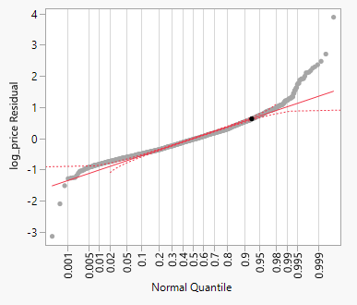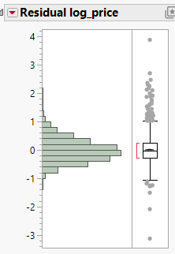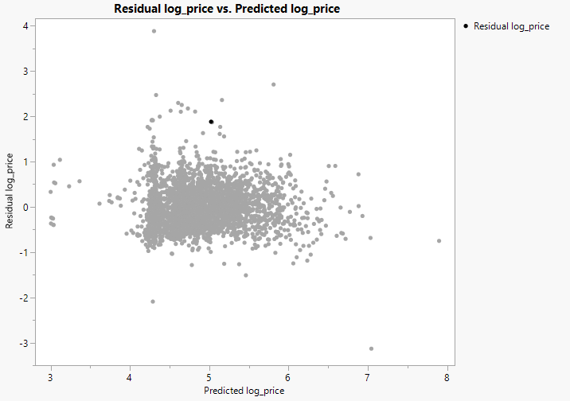
From the diagnostic graphs above we can now see that the model assumptions are substantially improved compared to previous models. Residuals are more normally distributed and the normal quantile plot residuals more closely resemble the reference line, indicating improved normality. The residuals vs predicted plot no longer exhibits a funnel shape (seen in model 1 and 2) suggesting that non-constant variance has been reduced. There are still outliers present and visible but it appears the assumption of homoscedasticity has been reasonably satisfied. Model 3 provides a much better fit for the data.
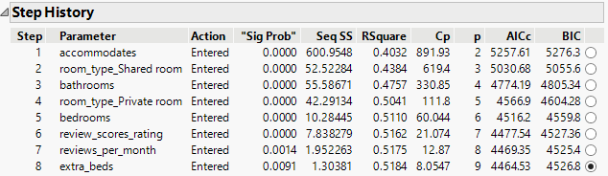
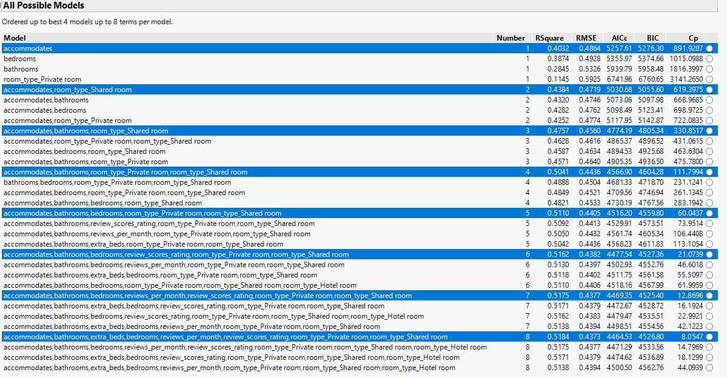
Unfortunately, the stepwise and all possible model outcomes don’t offer any big insights that could not have been seen previously. We will use the output from these to determine our final model for use.
Model 04:
Model 04 is meant to piggy back off model 03 using all possible models analysis to construct a simpler model. The goal is to determine whether a simpler model can maintain similar explanatory power while removing variables that do not contribute meaningfully.
$$E\left\{\log\left(y\right)\right\}=β_{0}+β_{1}x_{1}+ β_{2}x_{2}+ β_{3}x_{3}+β_{4}x_{4}+β_{5}x_{5}+β_{6}x_{6}+ β_{7}x_{7}+ β_{8}x_{8}$$
Hypothesis:
$$H_{O} : β_{i}=0 where i=1-8$$
$$H_{A} :at least one β_{i} ≠0 where β_{i}=1-8$$
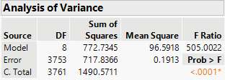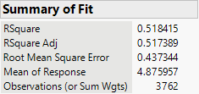
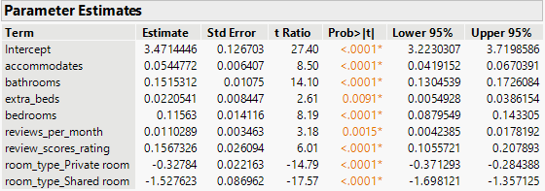
Model 4 explains ~51.8% of the variation in log(price) and given our adj R² value is nearly identical, we can see that the number of predictors is appropriate. The overall F-test shows that the model is statistically significant, providing evidence that at least one of the betas is not equal to zero. We reject the null hypothesis and accept the alternative hypothesis. Model 4 maintains the accuracy from model 3 but with 1 fewer variable.
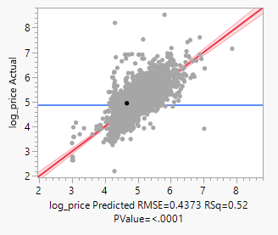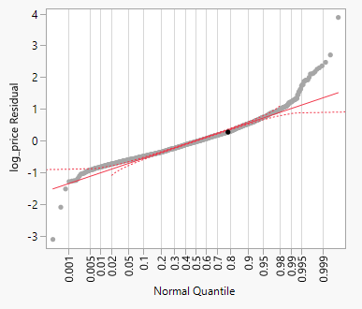
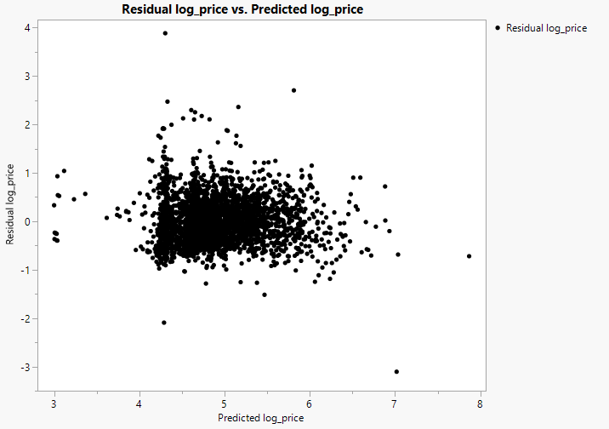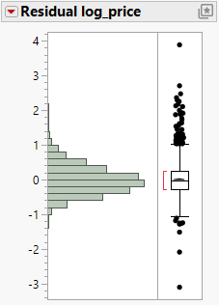
The residual diagnostics and findings about model assumptions show little to no change from model 3, further cementing the fact that model 4 is an incremental increase from model 3 without sacrificing performance. Model selection was supported by AIC and BIC values from all possible models analysis. Both log-transformed models offer much better results than models 1 and 2.
RESULTS
Model | Response | Predictors | R² | Adj R² | RMSE | F-stat | Prob > F
Model 1 | Price | 9 | 0.3005 | 0.299 | 141.78 | 179.08 | <0.0001
Model 2 | Price | 7 | 0.2869 | 0.2857 | 141.69 | 246.29 | <0.0001
Model 3 | Log(Price) | 9 | 0.5184 | 0.5173 | 0.4374 | 448.78 | <0.0001
Model 4 | Log(Price) | 8 | 0.5184 | 0.5174 | 0.4373 | 505.00 | <0.0001
Table 01: Model Comparison
The results from the model analysis can be seen from the table above. For detailed outputs and diagnostics on each individual model see the METHODS AND ANALYSIS portion of this report.
Exploratory analysis revealed that price is heavily right-skewed with a small number of highly priced listings influencing the distribution. This was always going to cause models with raw price as the predictor to be relatively weak and in violation of key model assumptions. Models 1 and 2 demonstrate this. To address this, the decision was made to transform raw price into log(price) which reduced skewness and stabilized variance. This would allow models to have more explanatory power and satisfy model assumptions.
A comparison of all 4 models showed that models 1 and 2, using raw price, only accounted for 29-30% of variation and violated regression assumptions. Once models 3 and 4, which used log(price) were tested, they explained ~51.8% of the variation each.
The final model selected is Model 4. It provides strong explanatory power, satisfies regression assumptions more effectively, and achieves the same level of performance as Model 3 while using fewer predictors. This balance of accuracy and simplicity makes Model 4 the most appropriate choice.
CONCLUSIONS AND DISCUSSION
The purpose of this analysis was to better understand what factors influence Airbnb listing prices and to develop a model that can reasonably explain those differences. The results show that the physical characteristics of a listing play the largest role in determining price. Listings that accommodate more guests, have more bathrooms and bedrooms, receive better reviews, and offer more privacy tend to have higher prices. This aligns with intuition, as larger and higher-quality listings generally provide more value.
Room type also has a meaningful impact on price. Compared to entire home or apartment listings, private rooms and shared rooms are lower in price. This is not surprising, as Airbnb listings are often used for travel, and privacy tends to be a valuable feature.
One of the most important findings in this analysis is that using raw price did not lead to models that performed well. This was expected, as the data was heavily skewed due to a small number of high-priced listings. By transforming price to a logarithmic scale, the models performed significantly better. This step was critical in developing a model that both fit the data well and satisfied key regression assumptions.
The final model explains over half of the variation in listing prices and provides a strong balance between accuracy and simplicity. Removing variables that did not contribute meaningfully helped simplify the model without reducing performance.
Overall, the analysis shows that price is primarily driven by size, layout, listing type, and reviews. While there is still some variation in price that is not explained by the model, these results directly answer the research question by showing that size, room type, and review-related factors are the primary drivers of Airbnb listing prices.
LIMITATIONS
This analysis is based on observational data, so the relationships identified represent associations rather than direct cause-and-effect relationships. Additionally, some factors that may influence price, such as location specifics, amenities, or seasonal demand (big one), were not included in the model. While the final model explains a significant portion of the variation in price, there is still unexplained variability.
Additionally, using a log transformation changes how the model is interpreted. The model predicts the logarithm of price rather than price itself, which means results must be converted back to the original scale for practical use. This can introduce slight bias when interpreting predicted prices and may make results less intuitive compared to models using raw prices.
APPENDIX
- I noticed that beds and bedrooms are highly correlated, since beds are basically determined by bedrooms. I didn’t want to use both as separate variables, but I still wanted to capture how much sharing is happening, since when looking at Airbnbs there’s usually a mix of people who are okay sharing a room and people who aren’t. So I created an “extra beds” variable (beds minus bedrooms) to reflect how many beds are beyond a one-bed-per-room setup, which helps capture that sharing aspect that could impact price.
- A quick look at outliers showed that it was not apparent that some incorrect information was entered, but that the information was correct. For example there was a listing that had 17 beds also had 7 bedrooms and accommodated 16 which would indicate that the data matches and 17 wasn’t linked to a listing with 1 bedroom that accommodates 2. Other examples of outliers followed suit.
- Because the model predicts log(price) you need to change the output back to the correct scale. For example if model 4 gives you $E\left\{\log\left(price\right)\right\}=5.3$ you would need to do $e^{5.3}=200.34$ and so $200.34 would be the expected price.
REFERENCES
https://insideairbnb.com/
Stat 311 coursework

